**USE CASE DIAGRAM**

**Student/User**

**Admin**

**Librarian**

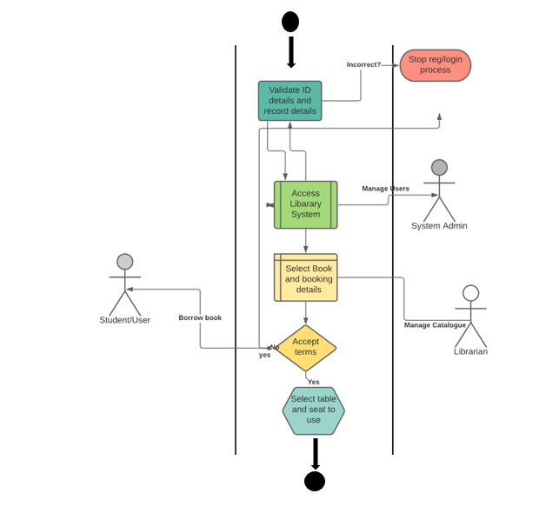

**ACTIVITY DIAGRAM**

The library information system

**SEQUENCE DIAGRAM**

Integrated Library information system

ILIS

***User. Student***

***Get details of book, payment and status***

Book entity details

***Send request to server to get book booking details***

Response from sever

Communication between users and system

***Book ID, ISBN, Author, Borrower***